PRZE-27

|  |  |
| --- | --- |
| BUG |  |
|  |  |

1. Ingresar url: <https://www.daypo.com/crear.php>

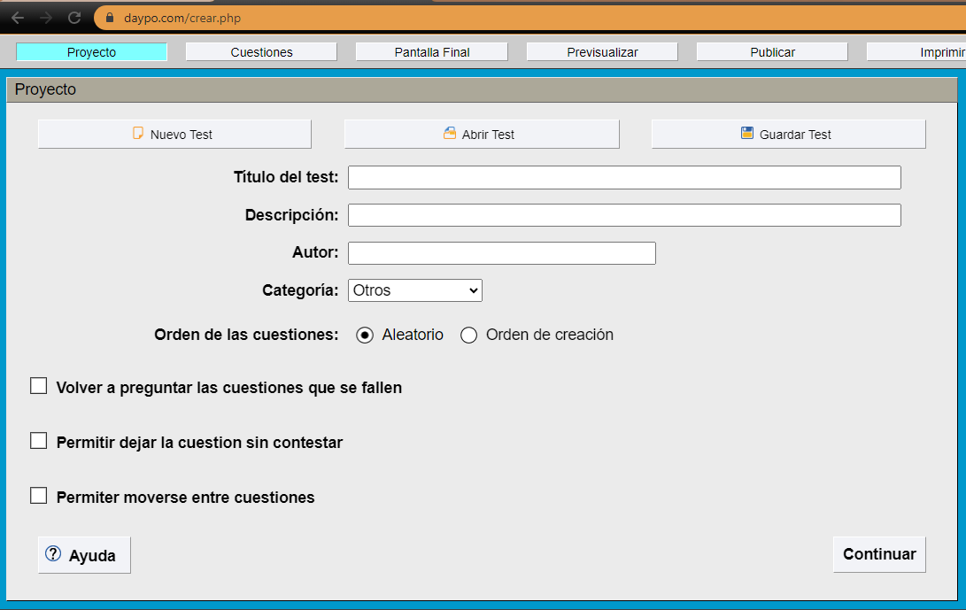

1. Dar click en SALIR

